TABLE OF CONTENTS

1.0 FIRST TIME ONLY SETUP STEPS: 2
1.1 COPY AND INSTALL dotnet-hosting-2.1.1-win.exe 2
1.2 SETUP THE CONFIG.INI FILE 2
1.3 CREATE THE AIMS3 APPLICATION POOL 3
1.4 HOW TO SETUP TOOLBELT FILES FROM FTP SERVER 5
2.0 HOW TO CREATE LICENSE FILE 7
3.0 FIRST-TIME AIMS3 LOG IN STEPS 8
4.0 HOW TO USE AUTO-UPDATER – Get info from Terry on Windows Service Updater to replace these instructions 11

How to Setup AIMS3 Local Test Instance

1.0 FIRST TIME ONLY SETUP STEPS:

1.1 COPY AND INSTALL dotnet-hosting-2.1.1-win.exe

What is the purpose of this executable? Add info here

- Go to R:\release\_BUILD\AIMS3

  - Copy dotnet-hosting-2.1.1-win.exe to your local pc

  - Run as Administrator

- Go to R:\release\_BUILD\AIMS3SiteUpdater\[All Files]

Copy the following files to your local AIMS_INSTALL\AIMS3 SiteUpdater folder
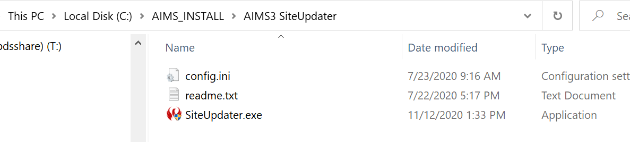

1.2 SETUP THE CONFIG.INI FILE

- Open the Config.ini file

- Confirm the FTP Information exists in the config file

- Enter the site directory path for your local AIMS3 instance for the directories line item.
NOTE: You can have multiple AIMS3 test sites separated by a comma
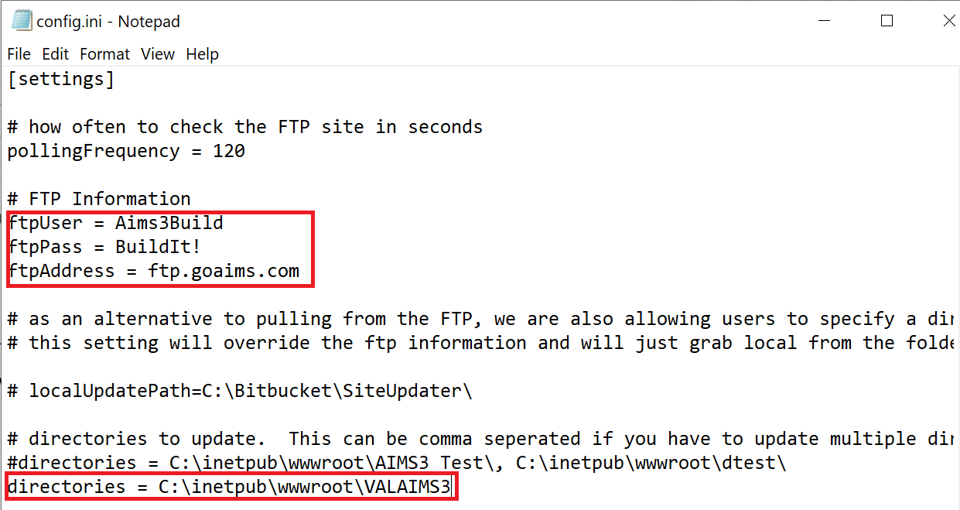

- Save the file

1.3 CREATE THE AIMS3 APPLICATION POOL

- Go to IIS Internet Information Services Manager (IIS)

- Expand connections and right-click click on Application Pools

- Enter name and select the following for the application pool
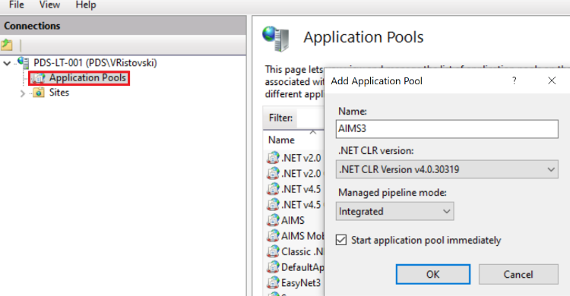

- Next, set up the credentials for the application pool. Right-click on Advanced Settings
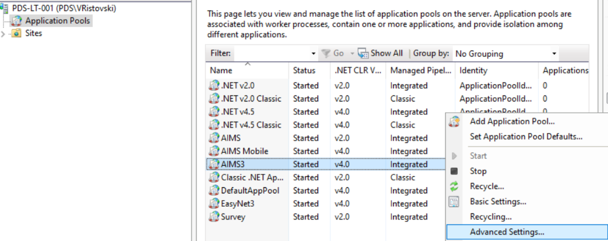

- Example: Set the Identity for the application pool for your local credentials
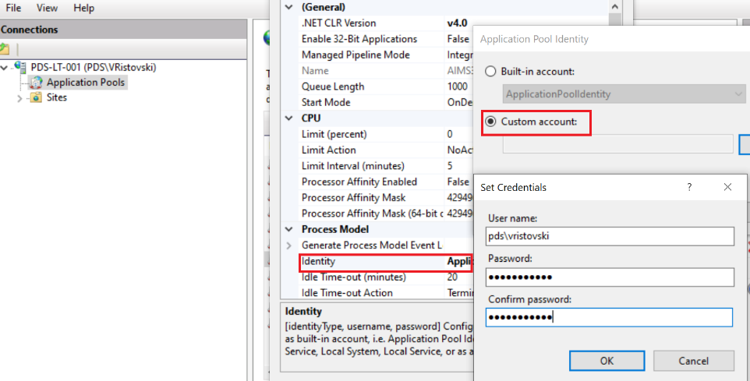

- Next, convert the application you created under Sites
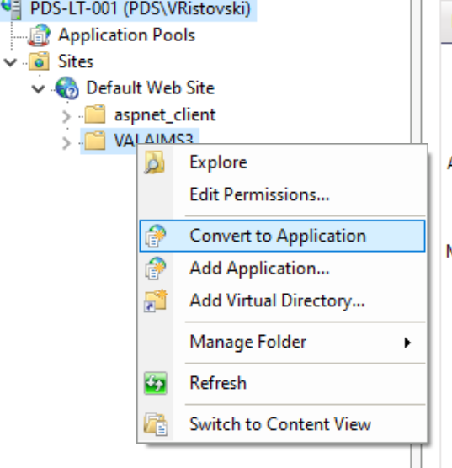

- Select the AIMS3 application pool you just created and click ok
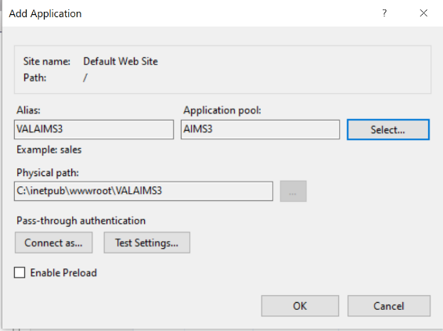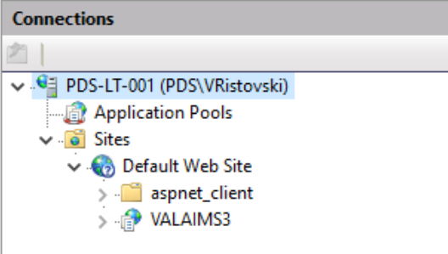

1.4 HOW TO SETUP TOOLBELT FILES FROM FTP SERVER

- Go to ftp.goaims.com and login using the credentials from the config.ini file

- Copy files from the ftp location to your local aims3 install folder
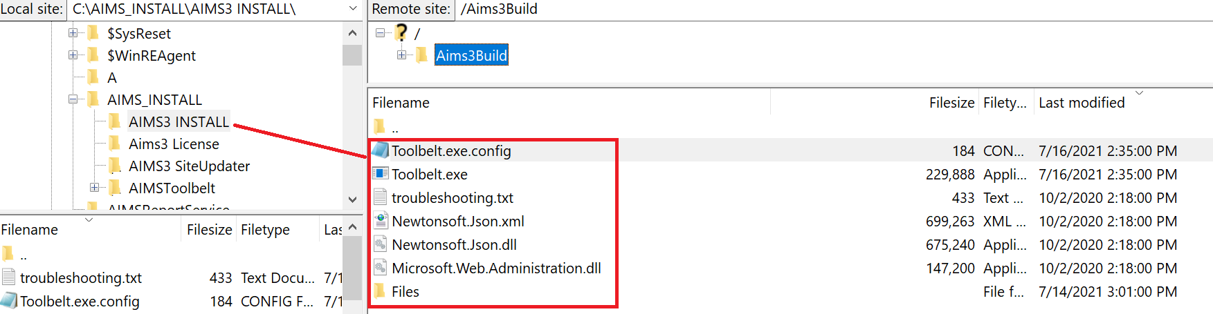

- Go to your AIMS Install folder and run Toolbelt.exe
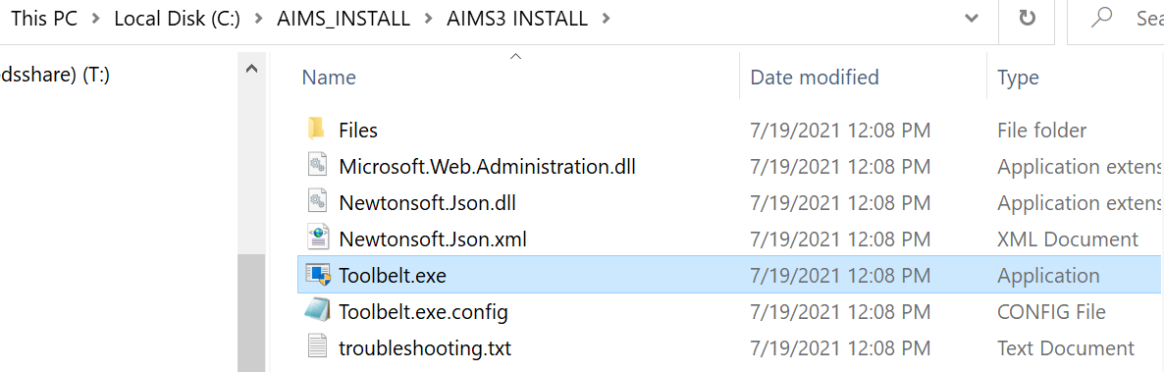

- Select <New> to create AIMS3 instance
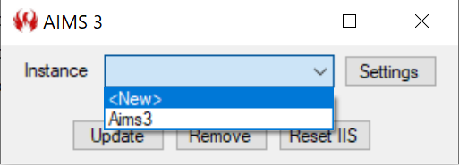

- Set up the configuration using example below and click on Update
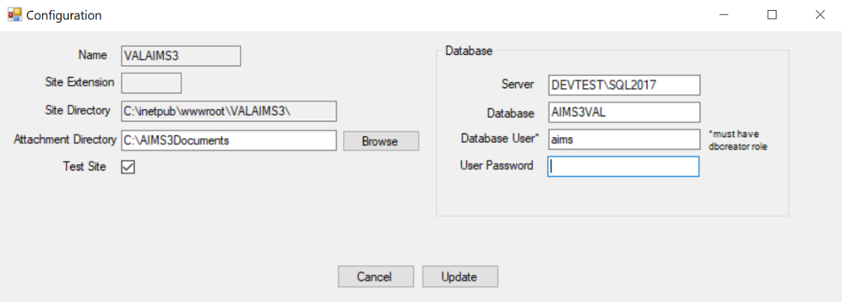

Name: | The name of the instance that will appear in the drop list
Site Extension: | Field be used to distinguish between the different instances
Site Directory: | Create a site in inetpub\wwwroot\
Server: | Server\SQL Instance  NOTE: You do not need an ODBC connection for AIMS3
Database: | Type a name for your database
Database User: | Can be any database user. User must have dbcreator role
User Password: | This is the password for the database user
Attachment Directory: | This is the location where you upload document attachments for work orders and equipment and where they are stored. It is also needed for reports.  The directory needs to have the same credentials running the application pool write access.
Test Site checkbox: | The purpose of turning on this option is to flag an aims3 instance as a TEST SITE which is indicated with the yellow theme visual indicator

- Click Yes to configure IIS
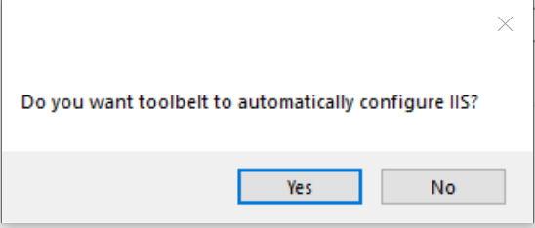

2.0 HOW TO CREATE LICENSE FILE

The license file works like a stamp fil and will have pre-loaded information specific to the customer serial number that is entered. For testing use 999

- Go to http://pds901v/aims3license
- Enter 999 for the Serial Number and hit tab to see the defined fields
- Click on Generate License File and it will automatically get created in your Downloads folder
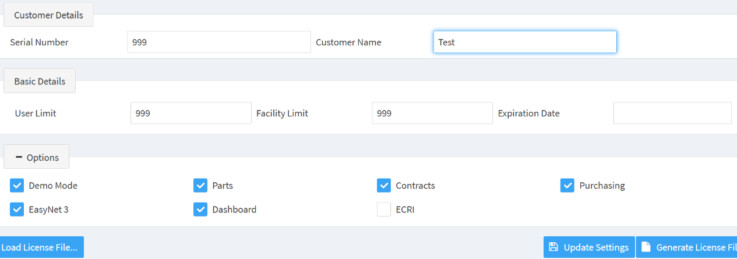

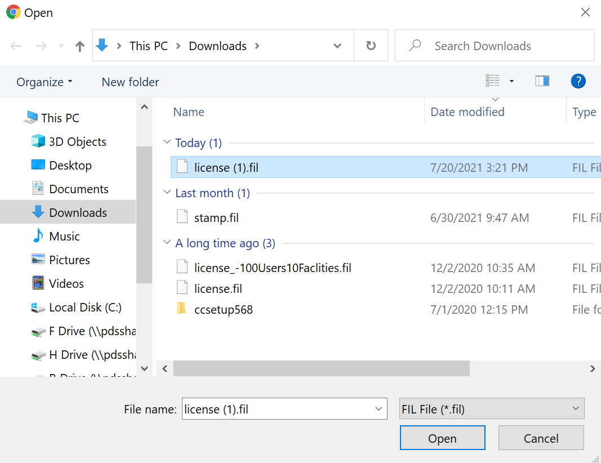

3.0 FIRST-TIME AIMS3 LOG IN STEPS

NOTE: The firebird password string is stored in the in c:\inetpub\www\your AIMS3 Instance \appsettings.json

- Locate the appsettings.json file
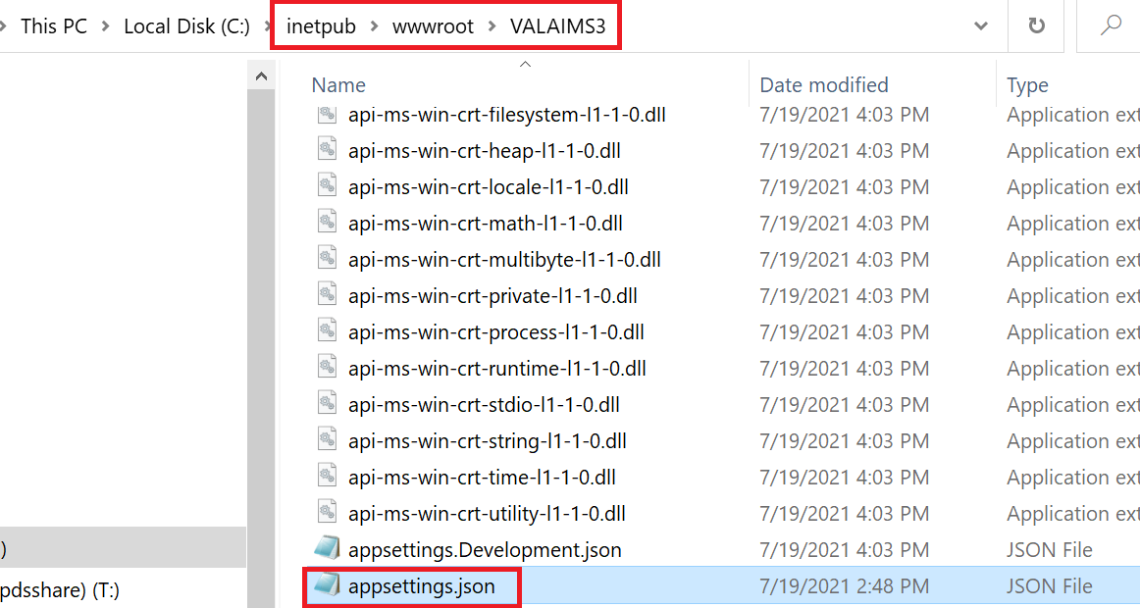

- Open the appsettings.json file in Notepad and you will see the following contents and most of the values were set during the Toolbelt process. Note the Firebird Password string.

{
"DbConnection": "Server=DEVTEST\\SQL2017;Database=AIMS3ValR;User Id=aims;password=Pds24293;Trusted_Connection=False;ConnectRetryCount=0",
"SecurityKey": "8ba419e0-105d-416d-a349-345b171774f0",
"AttachmentDirectory": "C:\\AIMS3Documents",
"PathBase": "AIMS3",
"Logging": {
"IncludeScopes": false,
"Debug": {
"LogLevel": {
"Default": "Warning"
}
},
"Console": {
"LogLevel": {
"Default": "Warning"
}
}
},
"FirebirdPassword": "cb02efc7-d738-4891-ab14-e5e7eed24e71",
"Extension": "",
"TestSite": false,
"TelerikHostAppId": "AIMSReportVALAIMS3"
}

  - Access your AIMS3 site that you created http://pds-lt-001/VALAIMS3/

NOTE: Upon accessing the AIMS3 URL for the very first time is when the AIMS3
database instance gets created and will show up in SQL

  - Enter id – firebird
  - Copy/paste the password string from the json file
  - Click Sign In

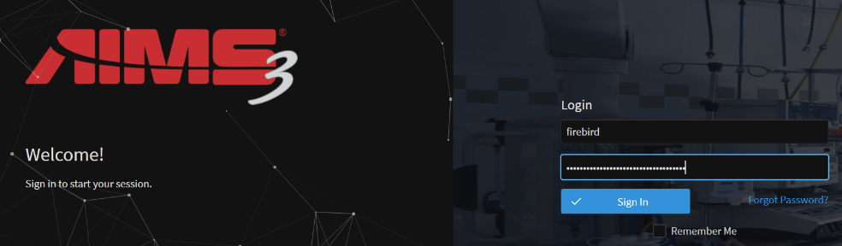

  - You will be prompted to load a license file

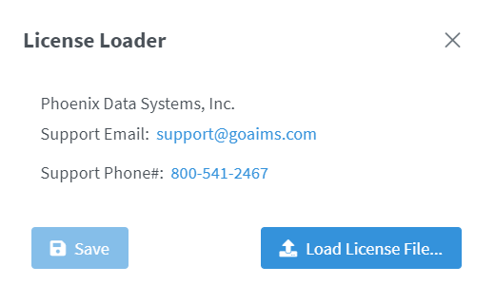

  - Select the license file you generated in the previous step in your Downloads folder

  - After you load the license file you will get logged in Administrator with limited access

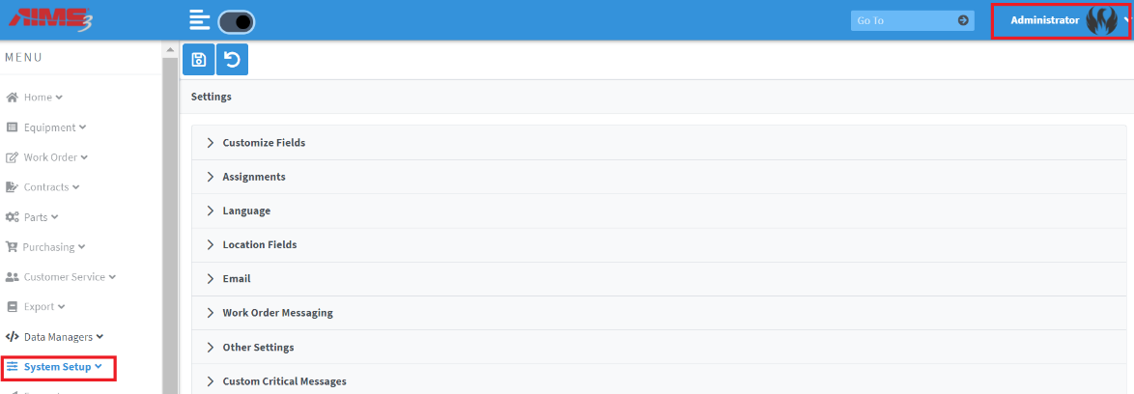

  - In Data Managers Employees- Create User Name (you login id)

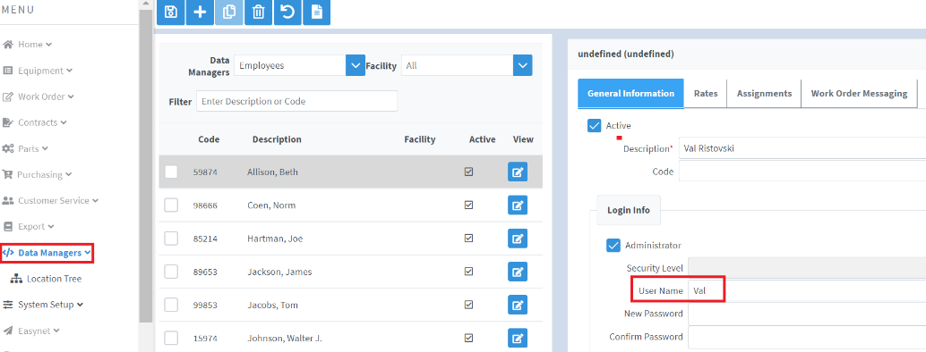

4.0 HOW TO USE AUTO-UPDATER – Get info from Terry on Windows Service Updater to replace these instructions

Explain how auto updater works add detail here – it pulls the latest code from the FTP server to refresh the application

- Go to your local AIMS3 SiteUpdater folder and run as Administrator
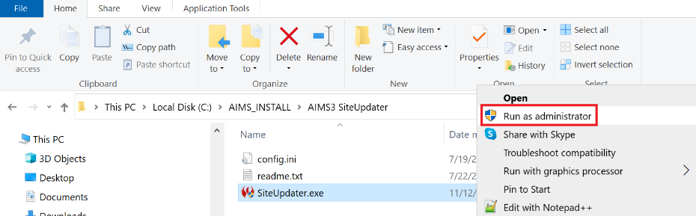

- This process copies the latest AIMS3 build from the FTP location to your local AIMS3 folder. By letting this process run in the background it will detect if there are any new version updates which will automatically update your local files.

